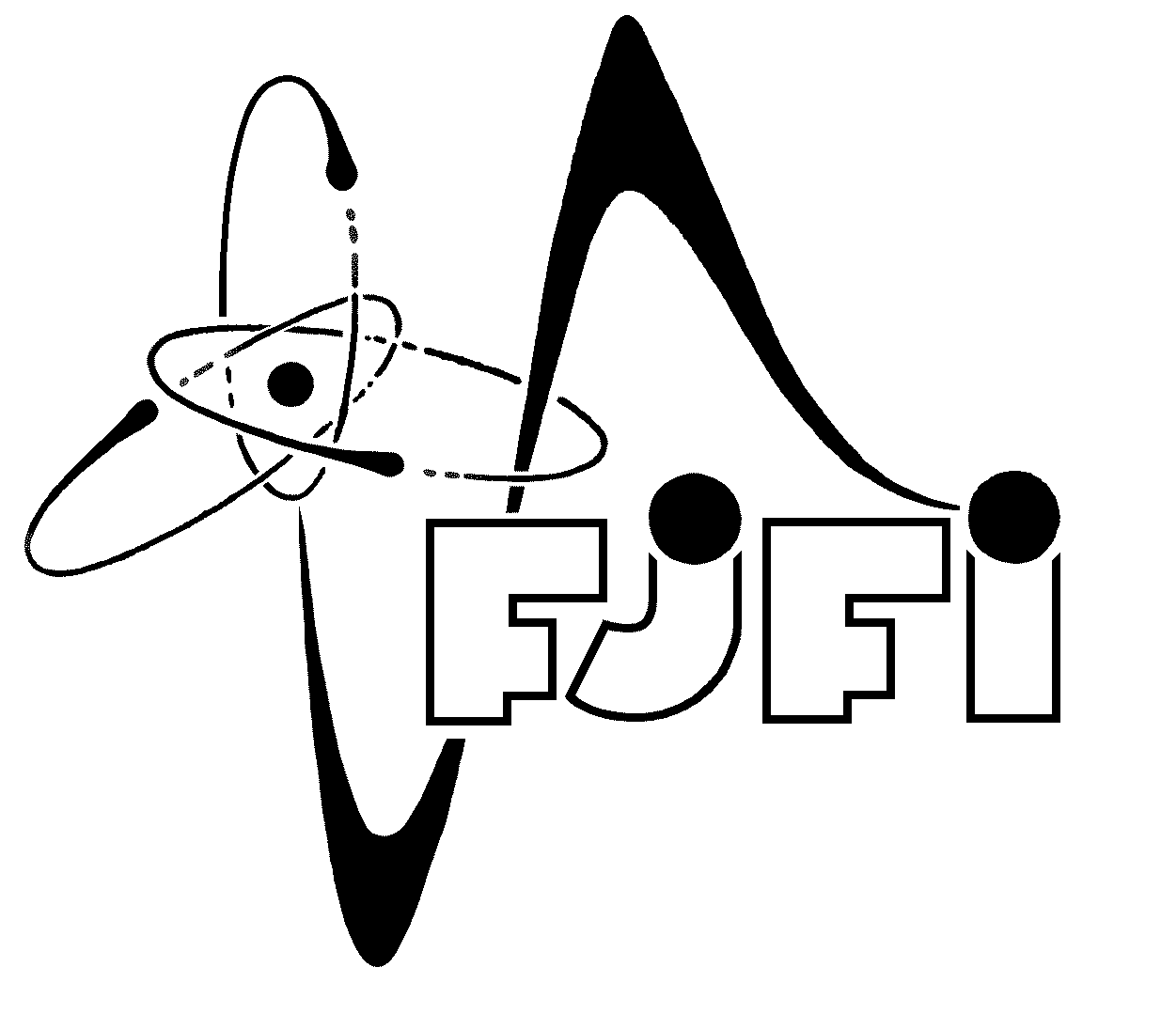
C Z E C H T E C H N I C A L U N I V E R S I T Y I N P R A G U E
FACULTY OF NUCLEAR SCIENCES AND PHYSICAL ENGINEERING
Břehová 7, 115 19 Praha 1, Czech Republic

PRAGUE WORKSHOP
ON RADIOLOGICAL PHYSICS
Prague, 11. – 13. January 2010

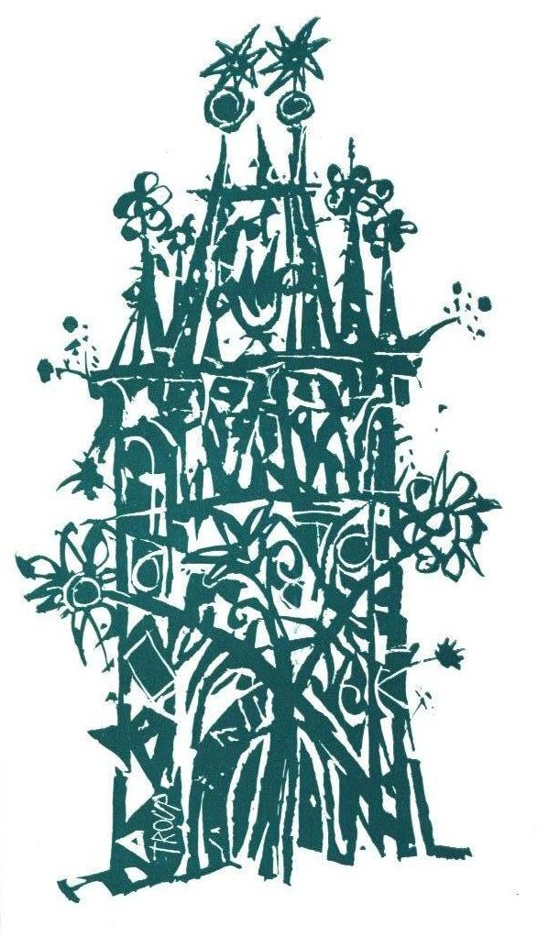

PRAGUE WORKSHOP
ON RADIOLOGICAL PHYSICS
Prague, 11. – 13. January 2010

Workshop topics

1) Monte Carlo in radiotherapy, nuclear medicine, and diagnostic imaging
2) Dose calculation and optimization for radiation therapy
3) Clinical dosimetry, verification, and modern treatment modalities

Organizing committee:

Prof. Tomáš Čechák, Czech Technical University – Faculty of Nuclear Sciences and Physical Engineering (CTU FNSPE)
Ing. Kateřina Vávrů, Czech Technical University – Faculty of Nuclear Sciences and Physical Engineering (CTU FNSPE)
Ing. Jitka Šemnická, Czech Technical University – Faculty of Nuclear Sciences and Physical Engineering (CTU FNSPE) / Na Homolce Hospital

Further information for participants

Workshop place:
CTU FNSPE, Břehová 7, 11519 Praha 1

FREE ENTRY, no participation fee is required.
Accommodation is not arranged by organizing committee.

Venue and transportation:
CTU FNSPE, Břehová 7, 11519 Praha 1:
Staroměstská stop: trams 17, 18, metro A, bus 133
Právnická fakulta stop: tram 17, bus 133

Prof. Tomáš Čechák, KDAIZ FJFI CVUT, Břehová 7, CZ 11519, Praha1, Czech Republic
tomas.cechak@fjfi.cvut.cz tel.No: +420 224 358 255
Ing. Kateřina Vávrů, KDAIZ FJFI CVUT, Břehová 7, CZ 11519, Praha1, Czech Republic
katerina.vavru@fjfi.cvut.cz tel.No: +420 224 358 239
PROGRAMME

Monday 11th January
Time | Speaker | Title
9:00 - 9:15 | Registration
9:15 - 9:30 | Welcome T. Čechák
Monte Carlo in radiotherapy, nuclear medicine, and diagnostic imaging
9:30 - 11:00 | M. Bazalová | Monte Carlo in radiotherapy 1 (introduction, overview of available codes and their applications in radiotherapy)
11:00 - 11:30 | Coffee break
11:00 - 12:30 | M. Bazalová | Monte Carlo in radiotherapy 2 (EGSnrc codes, issues, applications, examples)
12:30 - 14:00 | Lunch break
14:00 - 14:45 | J. Pipek | Geant4 in Radiotherapy: Model of LGK
14:45 - 15:30 | J. Mužík | Monte Carlo vs. Pencil Beam based optimization of stereotactic lung IMRT
15:45 - 16:30 | T. Urban | Shielding Calculations for Proton Therapy Center in Prague, Czech Republic

Tuesday 12th January
Time | Speaker | Title
Dose calculation and optimization for radiation therapy
9:30 - 11:00 | L. Bogner | Inverse MC optimization with photons and protons
11:00 - 11:30 | Coffee break
11:00 - 12:30 | T. Dirscherl | Biological optimization and dose-painting-by-numbers
12:30 - 14:00 | Lunch break
14:00 - 14:45 | M. Bazalová | Computed Tomography
14:45 - 15:30 | M. Bazalová | Metal artifacts in computed tomography and their influence on dose calculations
15:45 - 16:30 | O. Konček | Application of pencil beam algorithm for relative dose calculation from cobalt unit

Wednesday 13th January
Time | Speaker | Title
Clinical dosimetry, verification, and modern treatment modalities
9:30 - 11:00 | M. Bazalová | Dual-energy CT for dose calculations
11:00 - 11:30 | Coffee break
11:00 - 12:30 | J. Novotný | Leksell gamma knife Perfexion
12:30 - 14:00 | Lunch break
14:00 - 14:45 | M. Navrátil | Influence of errors in patient positioning on resulting dose distribution during IMRT
15:00 - 15:45 | K. Vávrů | Gel dosimetry - introduction, gel types, read-out methods
15:45 - 16:30 | J. Šemnická | Gel dosimetry at CTU
16:30 - 17:00 | End of the workshop

Programme changes reserved

